**Topics: Normal distribution, Functions of Random Variables**

1. **The time required for servicing transmissions is normally distributed with *μ* = 45 minutes and *σ* = 8 minutes. The service manager plans to have work begin on the transmission of a customer’s car 10 minutes after the car is dropped off and the customer is told that the car will be ready within 1 hour from drop-off. What is the probability that the service manager cannot meet his commitment?**
2. **0.3875**
3. **0.2676**
4. **0.5**
5. **0.6987**

**Solution:**  **B**. Since work begins 10 mins after car is dropped, the time left to complete work is 50 mins. Probability that services manager cannot meet his commitment = P(X>50) =1-Pr(x<=50) (X is the time taken to complete work). Convert 50 to z score.

Standard normal variable = Z = (X-u)/ σ = (x-45)/8

P(X<=50) = P(Z<=(50-45)/8)=PR(Z<=0.625)=0.73237=73.23%.

Probability that service manager will not meet his commitment = 100-73.237 = 26.376% = 0.2676.

1. **The current age (in years) of 400 clerical employees at an insurance claims processing center is normally distributed with mean *μ* = 38 and Standard deviation *σ* =6. For each statement below, please specify True/False. If false, briefly explain why.**
2. **More employees at the processing center are older than 44 than between 38 and 44.**

**Solution:** u = 38, σ = 6

Probability of employee > 44= Pr(x>4)=1-Pr(x<=44)

Z=(X-u)/ σ = (X-38)/6

Pr(X<=44) =Pr(z<=(44-38)/6)=Pr(Z<=1)=0.84134=84.134%

So, the statement “More employees at processing center are older than 44 than between 38 and 44” is True.

1. **A training program for employees under the age of 30 at the center would be expected to attract about 36 employees.**

**Solution:** Probability employees less than 30=Pr(X<30)

Z=(X-u)/ σ=(30-38)/6

Pr(x<30)=Pr(z<(30-38)/6)=Pr(z<1.333) = 0.0917=9.17%

The statement of ‘training program for employees under the age of 30 at the center world be expected to attract about 36 employees” is True.

1. **If *X1* ~ *N*(μ, σ2) and *X*2 ~ *N*(μ, σ2) are *iid* normal random variables, then what is the difference between 2 *X*1 and *X*1 + *X*2? Discuss both their distributions and parameters.**

**Solution:**  The normal distribution has its link with the central limit theorem.

The difference between 2X1 and (X1+X2) is the magnitude they hold of two different sample subsets (x1 and x2) from the same source. X1 and X2 can be different subset of a sample from similar source but if ***X1* ~ *N*(μ, σ2)**  *then* ***X*2 ~ *N*(μ, σ2),** hence 2X1-(X1+X2)~(2u-2u,4 σ2+2 σ2), so we conclude that distribution fall under normal distribution and slight deviation in parameters.

1. **Let X ~ N(100, 202). Find two values, *a* and *b*, symmetric about the mean, such that the probability of the random variable taking a value between them is 0.99.**
2. **90.5, 105.9**
3. **80.2, 119.8**
4. **22, 78**
5. **48.5, 151.5**
6. **90.1, 109.9**

**Solution: D.**

The probability of getting value between a & b is 0.99

so, the probability of getting value outside a & b is 1-0.99=0.01

The probability towards left of a = -0.01/2=-0.05

The probability towards right of b = 0.01/2 = 0.05

Since we have probabilities of a & b, we need calculate the probability of X

Z=(X-u)/ σ

Z* σ+ u = x

-(-2.57) *20+100=151.4

-(2.57) *20+100=48.6

1. **Consider a company that has two different divisions. The annual profits from the two divisions are independent and have distributions Profit1 ~ N(5, 32) and Profit2 ~ N(7, 42) respectively. Both the profits are in $ Million. Answer the following questions about the total profit of the company in Rupees. Assume that $1 = Rs. 45**

**Solution:** 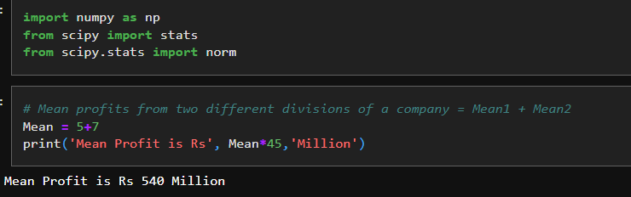

1. **Specify a Rupee range (centered on the mean) such that it contains 95% probability for the annual profit of the company.**

**Solution:** 

1. **Specify the 5th percentile of profit (in Rupees) for the company**

**Solution:** 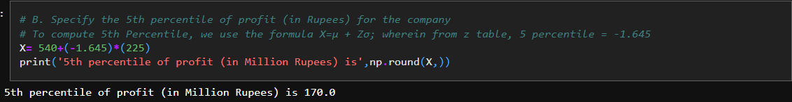

1. **Which of the two divisions has a larger probability of making a loss in a given year?**

**Solution:** 